Sample off Tark report, what it generates

Model path diagram
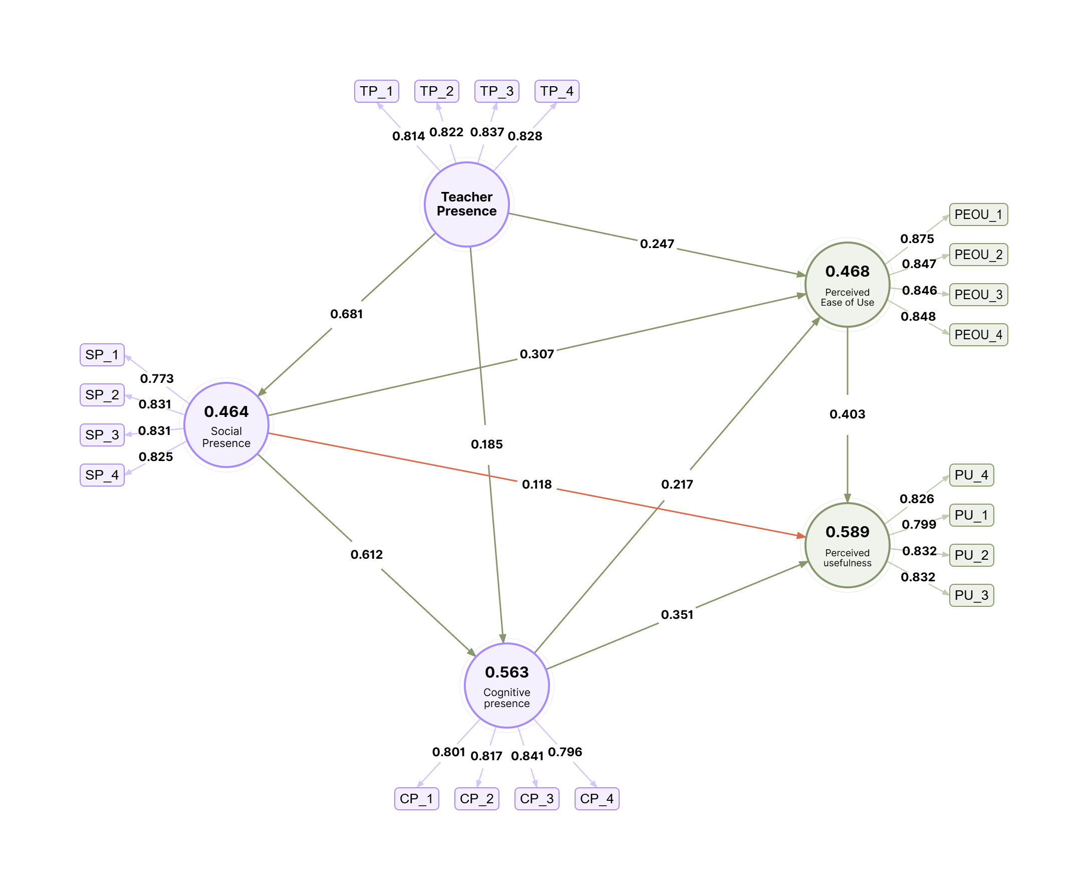
Figure 1. Model path diagram.

Measurement model assessment
Table 1
Measurement model assessment
Construct | Indicator | Loading | VIF | Cronbach’s α | rho_A | CR | AVE
Teacher Presence | TP_1 | 0.814 | 1.822 | 0.844 | 0.846 | 0.895 | 0.681
 | TP_2 | 0.822 | 1.865
 | TP_3 | 0.837 | 1.954
 | TP_4 | 0.828 | 1.803
Social Presence | SP_1 | 0.773 | 1.591 | 0.831 | 0.834 | 0.888 | 0.664
 | SP_2 | 0.831 | 1.910
 | SP_3 | 0.831 | 1.921
 | SP_4 | 0.825 | 1.775
Cognitive presence | CP_1 | 0.801 | 1.738 | 0.830 | 0.832 | 0.887 | 0.662
 | CP_2 | 0.817 | 1.837
 | CP_3 | 0.841 | 1.956
 | CP_4 | 0.796 | 1.612
Perceived Ease of Use | PEOU_1 | 0.875 | 2.455 | 0.876 | 0.878 | 0.915 | 0.730
 | PEOU_2 | 0.847 | 2.258
 | PEOU_3 | 0.846 | 2.166
 | PEOU_4 | 0.848 | 2.100
Perceived usefulness | PU_4 | 0.826 | 1.899 | 0.840 | 0.841 | 0.893 | 0.676
 | PU_1 | 0.799 | 1.795
 | PU_2 | 0.832 | 1.966
 | PU_3 | 0.832 | 1.997
Note. Loading = outer loading; VIF = variance inflation factor; rho_A = Dijkstra-Henseler rho; CR = composite reliability; AVE = average variance extracted.

Discriminant validity assessment
Table 2
Discriminant validity assessment
Construct | Teacher Presence | Social Presence | Cognitive presence | Perceived Ease of Use | Perceived usefulness
Teacher Presence | — | — | — | — | —
Social Presence | 0.810 | — | — | — | —
Cognitive presence | 0.717 | 0.883 | — | — | —
Perceived Ease of Use | 0.679 | 0.743 | 0.690 | — | —
Perceived usefulness | 0.690 | 0.756 | 0.807 | 0.796 | —
Note. Values report HTMT ratios. Values below the selected threshold support discriminant validity.

Structural model assessment
Table 3
Structural model assessment
Hypothesis | Path | β | Mean | STDEV | t-value | p-value | 95% CI | f² | Effect size | Decision
 | Teacher Presence → Social Presence | 0.681 | 0.683 | 0.050 | 13.665 | <.001 | [0.577, 0.772] | 0.866 | Large | Supported
 | Teacher Presence → Cognitive presence | 0.185 | 0.186 | 0.070 | 2.628 | 0.009 | [0.046, 0.320] | 0.042 | Small | Supported
 | Teacher Presence → Perceived Ease of Use | 0.247 | 0.251 | 0.066 | 3.727 | <.001 | [0.125, 0.387] | 0.059 | Small | Supported
 | Social Presence → Cognitive presence | 0.612 | 0.612 | 0.062 | 9.934 | <.001 | [0.492, 0.730] | 0.458 | Large | Supported
 | Social Presence → Perceived Ease of Use | 0.307 | 0.303 | 0.071 | 4.293 | <.001 | [0.160, 0.444] | 0.065 | Small | Supported
 | Social Presence → Perceived usefulness | 0.118 | 0.121 | 0.064 | 1.839 | 0.050 | [-0.000, 0.252] | 0.014 | None | Not supported
 | Cognitive presence → Perceived Ease of Use | 0.217 | 0.216 | 0.079 | 2.751 | 0.006 | [0.061, 0.370] | 0.039 | Small | Supported
 | Cognitive presence → Perceived usefulness | 0.351 | 0.349 | 0.064 | 5.472 | <.001 | [0.218, 0.471] | 0.127 | Small | Supported
 | Perceived Ease of Use → Perceived usefulness | 0.403 | 0.403 | 0.052 | 7.689 | <.001 | [0.298, 0.504] | 0.221 | Medium | Supported
Note. β = standardized path coefficient; STDEV = bootstrap standard deviation; CI = confidence interval; f² = effect size.

Specific indirect effects
Table 4
Specific indirect effects
Path | β | STDEV | t-value | p-value | 2.5% CI | 97.5% CI
Teacher Presence → Cognitive presence → Perceived Ease of Use | 0.040 | 0.022 | 1.809 | 0.016 | 0.005 | 0.090
Teacher Presence → Cognitive presence → Perceived usefulness | 0.065 | 0.028 | 2.293 | 0.009 | 0.014 | 0.125
Teacher Presence → Social Presence → Cognitive presence | 0.417 | 0.054 | 7.742 | <.001 | 0.322 | 0.528
Teacher Presence → Social Presence → Perceived usefulness | 0.081 | 0.045 | 1.804 | 0.050 | -0.000 | 0.173
Teacher Presence → Social Presence → Perceived Ease of Use | 0.209 | 0.050 | 4.216 | <.001 | 0.112 | 0.308
Teacher Presence → Perceived Ease of Use → Perceived usefulness | 0.099 | 0.028 | 3.568 | <.001 | 0.049 | 0.158
Cognitive presence → Perceived Ease of Use → Perceived usefulness | 0.087 | 0.036 | 2.401 | 0.006 | 0.022 | 0.163
Social Presence → Cognitive presence → Perceived Ease of Use | 0.133 | 0.051 | 2.604 | 0.006 | 0.035 | 0.235
Social Presence → Cognitive presence → Perceived usefulness | 0.215 | 0.043 | 4.996 | <.001 | 0.133 | 0.302
Social Presence → Perceived Ease of Use → Perceived usefulness | 0.124 | 0.031 | 3.960 | <.001 | 0.064 | 0.186
Note. β = specific indirect effect; STDEV = bootstrap standard deviation; CI = bootstrap confidence interval. The displayed bounds are the standard 95% interval limits (2.5% and 97.5%).

Explanatory and predictive power
Table 5
Explanatory and predictive power
Endogenous construct | R² | Adjusted R² | R² interpretation | Q²predict | Q²predict interpretation
Cognitive presence | 0.563 | 0.560 |  | 0.360
Social Presence | 0.464 | 0.463 |  | 0.460
Perceived Ease of Use | 0.468 | 0.463 |  | 0.343
Perceived usefulness | 0.589 | 0.585 |  | 0.334
Note. R² and adjusted R² are from the PLS-SEM estimate. Q²predict values are from the PLSpredict latent variable (LV) summary.

Model fit assessment
Table 6
Model fit assessment
Fit index | Value
SRMR | 0.057
d_ULS | 0.683
d_G | 1.926
NFI | 0.983
Note. Model fit reports SRMR, NFI, d_ULS, and d_G from the fitted Standard PLS or PLSc model.

PLSpredict assessment
Table 7
PLSpredict assessment
Indicator | Q²predict | PLS RMSE | PLS MAE | LM RMSE | LM MAE
SP_1 | 0.236 | 0.816 | 0.626 | 0.821 | 0.626
SP_2 | 0.364 | 0.749 | 0.578 | 0.750 | 0.575
SP_3 | 0.303 | 0.803 | 0.611 | 0.798 | 0.611
SP_4 | 0.308 | 0.813 | 0.610 | 0.824 | 0.619
CP_1 | 0.213 | 0.812 | 0.630 | 0.820 | 0.633
CP_2 | 0.229 | 0.846 | 0.640 | 0.858 | 0.649
CP_3 | 0.261 | 0.822 | 0.631 | 0.831 | 0.635
CP_4 | 0.224 | 0.814 | 0.630 | 0.819 | 0.630
PEOU_1 | 0.256 | 0.853 | 0.641 | 0.866 | 0.651
PEOU_2 | 0.229 | 0.889 | 0.705 | 0.888 | 0.697
PEOU_3 | 0.227 | 0.898 | 0.694 | 0.899 | 0.700
PEOU_4 | 0.278 | 0.876 | 0.667 | 0.880 | 0.663
PU_4 | 0.244 | 0.851 | 0.669 | 0.867 | 0.677
PU_1 | 0.221 | 0.860 | 0.686 | 0.864 | 0.686
PU_2 | 0.240 | 0.886 | 0.717 | 0.894 | 0.719
PU_3 | 0.179 | 0.874 | 0.694 | 0.882 | 0.702
Note. Q²predict values above zero indicate predictive relevance. PLS and LM errors support comparison of predictive performance.

